GREATER CAIRO
METRO LINE No.3
TCMS-IO interface Specification

Approved by | 21.Aug.2019 | K.K. SHIN | 
Reviewed by | 21.Aug.2019 | S.J. SEO | 
Written by | 21.Aug.2019 | H.KIM | 
 | Date | Name | Signature

Revision History
Issue | Page | Revision |  | Date
Issue | Page | From | To | Date
0 |  | First issue |  | 05.Dec.2013
1
2
3
4
5
6
7
8
9
10
11
12
13
14
15
16

Contents
1. Introduction 4
2. LIST OF ABBREVIATIONS 4
3. GENERAL 5
3.1. MVB Specification 5
3.2. MVB Connection 6
3.3. MVB Telegram 8
4. Data from TMS to IO-M 11
4.1. Port Address 11
4.2. TMS-IO-SDR 11
5. Data from IO-M to TMS 14
5.1. Port Address 14
5.2. IO-TCMS-SD 14

Introduction

This document explains the interface specification between TCMS and IO for Cairo3 project.

-. Reference Document
TMS MVB Network Specifications.(REDE200998)

LIST OF ABBREVIATIONS

APU Auxiliary Power supply Unit
CCU Central Control Unit
VCU Vehicle Control Unit
IO-M Remote IO-MVB
CRC Cyclic Redundancy Check
DU Display Unit
BECU Brake Electronic Control Unit
VVVF Variable Voltage Variable Frequency
DCU Door Control Unit
EMD Electrical Medium Distance
FCS Frame Check Sequence
HCR Head Control Relay
VAC Ventilating, and Air Conditioning (system)
MVB Multifunction Vehicle Bus
RS Rolling Stock
SD Status Data
SDR Status Data Request
TMS Train Management System
ARCNET Attached Resource Computer NETwork

GENERAL

TCMS and Remote IO system are interfaced with MVB. This document explains interface between TMS and RIO through MVB for Cairo3 project.

MVB Specification
General specification of MVB is explained as follow.
-. Redundancy : Line A, Line B
-. Master / Slave : TMS is only Master.
The subsystem needs not to act as bus administrator.
-. Media Support : EMD(Electrical Middle Distance) Communication Distance within
200m.

<Table 1. – Summary of the Multifunction Vehicle Bus by IEC 61375-1>
topology | bus(electrical)  star(optical)
Media | Electrical Short Distance  Electrical Middle Distance  Optical Glass Fibre | twisted wire pair, biased RS-485  shielded twisted wire pair, transformer coupled  200/240 µm fibres and star coupler
Length | Electrical Short Distance  Electrical Middle Distance  Optical Glass Fibre | 20 m, 32 devices per segment  200 m, 32 devices per segment  2000 m
Physical Redundancy | duplicated physical medium(synchronous send)
Signalling | Manchester II, 9-bit frame Start Delimiter
Signalling rate | 1.5 Mbit/s
Address space | 12-bit Device Address  (0…255 reserved for devices with Message Data capability)  12-bit Logical Address for Process Data  (each 16…256 bits)
Physical Addressing | single cast and broadcast
Frame size  (useful data) | 16, 32, 64, 128, 256 bits
Integrity | CRC-8 per 64bits + Manchester encoding, different frame Start Delimiter for Master Frame and Slave Frame against synchronization slip, reception time window supervision
Medium Allocation | by one centralized Master(Hyundai-Rotem’s CCU & VCU)
Traffic | periodic(mainly for Process Data)  sporadic(mainly for Message Data)  supervisory(for Supervisory Data)
Mastership Transfer | mastership transfer by token passing  several Bus Administrators can become Master in turn
Mastership Redundancy  (Option) | redundant Bus Administrators serve as back-up
Link Layer Service | Link Process Data Interface  Link Message Data Interface  Link Supervision Interface | broadcast of source addressed data  datagrams  Link Layer Management

MVB Connection
Where interchangeability is required, Subsystems connected by MVB shall be attached to
the cable as follow:

<Table 2. Pin assignment for the EMD Connector>
1 | A.Data_P positive wire of Line A | 6 | A.Term_P, Positive pole of Terminator Line A
2 | A.Data_N negative wire of Line A | 7 | A.Term_N, Negative pole of Terminator Line A
3 | Not Used | 8 | B.Term_P, Positive pole of Terminator Line B
4 | B.Data_P positive wire of Line B | 9 | B.Term_N, Negative pole of Terminator Line B
5 | B.Data_N negative wire of Line B

Note 1 It is recommend to arrange the two connectors side by side on a device, Connector 1 on the left and Connector 2 on the right, to thread the wiring neatly.
Note 2 It may be necessary to ensure that the connector case is isolated from the device case if connection of the device cases is not advisable, for instance when large stray currents are expected.

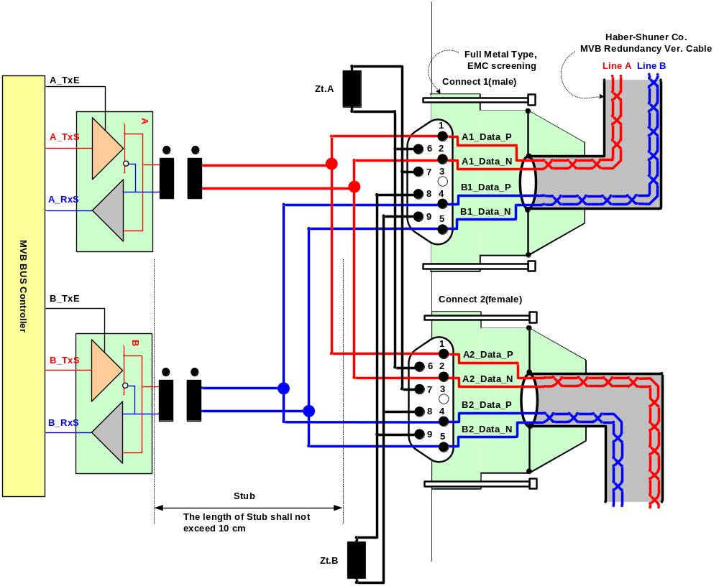
<Figure 1.Double line EMD connector arrangement>

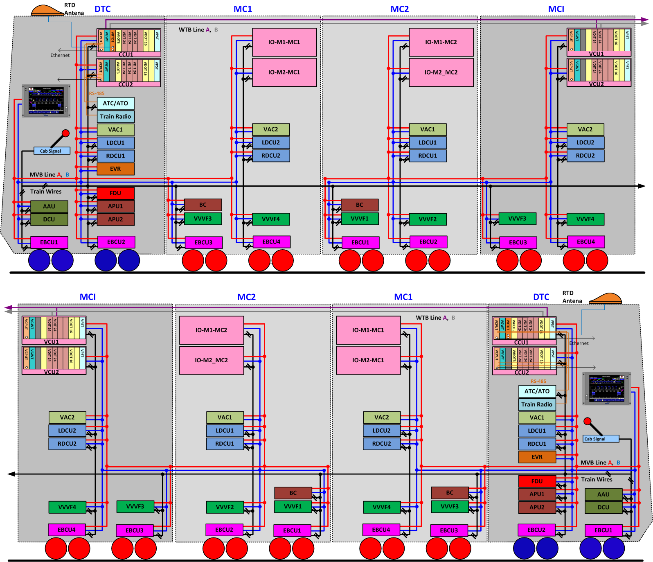
< Figure 2.Configuration >

MVB Telegram
There are 16 telegrams types on the MVB, which are distinguished by the F-code in Master Frame, as shown in Table 3. Hyundai-Rotem uses only the process data request(Fcode0-4)
<Table 3 F-code of the MVB(Master Frame Type)>
F-Code | Telegram Type
0 | Process Data Request with 16 bits
1 | Process Data Request with 32 bits
2 | Process Data Request with 64 bits
3 | Process Data Request with 128 bits
4 | Process Data Request with 256 bits
5 | (reserved)
6 | (reserved)
7 | (reserved)
8 | Mastership Transfer Request
9 | General Event Request
10 | (reserved)
11 | (reserved)
12 | Message Data Request
13 | Group Event Request
14 | Single Event Request
15 | Device Status Request
The basic data type for MVB network between TMS and sub-system is WORD. The byte order and bit order for a data are as follows. The byte ordering is Big-Endian(Motorola)
<bit order and bit mask>
WORD | Data Contents |  |  |  |  |  |  |  | Remark
WORD | Bit Mask |  |  |  |  |  |  |  | Remark
WORD | 15 | 14 | 13 | 12 | 11 | 10 | 9 | 8 | Remark
WORD | 7 | 6 | 5 | 4 | 3 | 2 | 1 | 0 | Remark
The bit 0 is the least significant bit(LSB) and the bit 15 is the most significant bit(MSB).
<byte order – in case of one 2byte-size data>
WORD | Data Contents |  |  |  |  |  |  |  | Remark
WORD | Bit Mask |  |  |  |  |  |  |  | Remark
WORD | 15 | 14 | 13 | 12 | 11 | 10 | 9 | 8 | Remark
WORD | 7 | 6 | 5 | 4 | 3 | 2 | 1 | 0 | Remark
0 | Watchdog Counter(0 – 65535), Life-sign – Most significant byte(MSB)
0 | Watchdog Counter(0 – 65535), Life-sign – Least significant byte(LSB)
<byte order – in case of two 1byte-size data>
WORD | Data Contents |  |  |  |  |  |  |  | Remark
WORD | Bit Mask |  |  |  |  |  |  |  | Remark
WORD | 15 | 14 | 13 | 12 | 11 | 10 | 9 | 8 | Remark
WORD | 7 | 6 | 5 | 4 | 3 | 2 | 1 | 0 | Remark
0
// | // |  |  |  |  |  |  |  | //
N | Data2 : 2*N+1th byte position in data frame.
N | Data1 : (2*N)th byte position in data frame.
Data1 is 2*Nth position and Data2 is 2*N+1th position in data frame.

The Byte Order issue must be considered carefully. Consider following cases: Motorola (Big Endian format) and Intel (Little Endian format). The left column in the following figure describes non-numeric data (character strings, stored in memory with incrementing address order). The right column describes numeric data (upper halfword contains obviously the more significant digits) words. The processors write the data (and as well the Force Mask and Force Data) into the Traffic Memory using their native Endian formats:

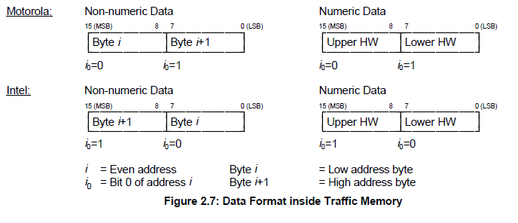
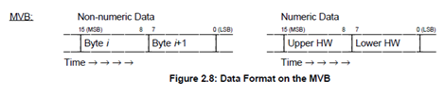

< Figure 4 MVB Byte Order>

Data from TMS to IO-M

Port Address
Telegram name | Source | Sink | Port  address | Fcode | Port Cycle
RE-IO1-SDR | TCMS | MC1/MC2 | 148H | 2 | T(≤64ms)
RE-IO2-SDR | TCMS | MC1/MC2 | 14CH | 2 | T(≤64ms)

TMS-IO-SDR
Below Table is the TMS source port data for IO-M:
WORD | Data Contents |  |  |  |  |  |  |  |  |  |  | Remark
WORD | Bit Mask |  |  |  |  |  |  |  |  |  |  | Remark
WORD | 15 | 14 | 13 | 12 | 11 |  | 10 |  | 9 |  | 8
WORD | 7 | 6 | 5 | 4 | 3 |  | 2 |  | 1 |  | 0
0
0 | Send data Counter(Watchdog : TMS increments)  (0~255)
1
2 | DO16 | DO15 | DO14 | DO13 | DO12 |  | DO11 |  | DO10 |  | DO9
2 | DO8 | DO7 | DO6 | DO5 | DO4 |  | DO3 |  | DO2 |  | DO1
3

WORD 0
Bit 0-7 | Send data Counter(Watchdog : TMS increments) | -. Range: 0 to 255 (00h to FFh)  -. TMS increments this bit every transmission cycle. DCU ignores the information in SDR if this counter is not incremented for more than "2000ms".
Bit 8
Bit 9
Bit 10
Bit 11
Bit 12
Bit 13
Bit 14
Bit 15

WORD 1
Bit 0
Bit 1
Bit 2
Bit 3
Bit 4
Bit 5
Bit 6
Bit 7
Bit 8
Bit 9
Bit 10
Bit 11
Bit 12

WORD 2
Bit 0 | DO1 | -. HIGH(1) : Command to output channel no.1
Bit 1 | DO2 | -. HIGH(1) : Command to output channel no.2
Bit 2 | DO3 | -. HIGH(1) : Command to output channel no.3
Bit 3 | DO4 | -. HIGH(1) : Command to output channel no.4
Bit 4 | DO5 | -. HIGH(1) : Command to output channel no.5
Bit 5 | DO6 | -. HIGH(1) : Command to output channel no.6
Bit 6 | DO7 | -. HIGH(1) : Command to output channel no.7
Bit 7 | DO8 | -. HIGH(1) : Command to output channel no.8
Bit 8 | DO9 | -. HIGH(1) : Command to output channel no.9
Bit 9 | DO10 | -. HIGH(1) : Command to output channel no.10
Bit 10 | DO11 | -. HIGH(1) : Command to output channel no.11
Bit 11 | DO12 | -. HIGH(1) : Command to output channel no.12
Bit 12 | DO13 | -. HIGH(1) : Command to output channel no.13
Bit 13 | DO14 | -. HIGH(1) : Command to output channel no.14
Bit 14 | DO15 | -. HIGH(1) : Command to output channel no.15
Bit 15 | DO16 | -. HIGH(1) : Command to output channel no.16

- Sequence of OUTPUT

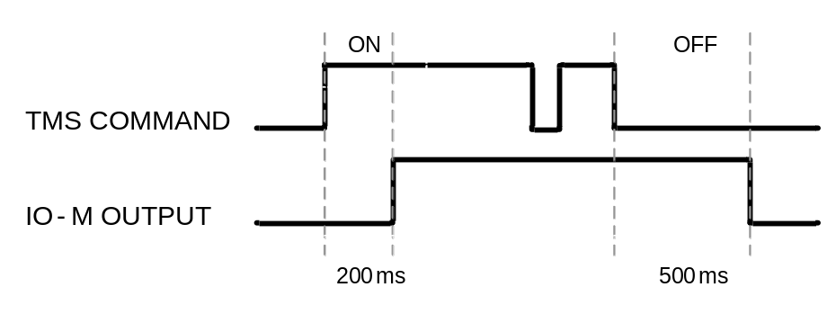

WORD 3
Bit 0-2
Bit 8
Bit 9
Bit 10-15

Data from IO-M to TMS

Port Address
Telegram name | Source | Sink | Port  address | Fcode | Port Cycle
RE-IO1-SD | MC1/MC2 | TCMS | 140H | 4 | T(≤64ms)
RE-IO2-SD | MC1/MC2 | TCMS | 144H | 4 | T(≤64ms)

IO-TCMS-SD
Below Table is the DCU source port data for TMS:
WORD | Data Contents |  |  |  |  |  |  |  |  |  |  |  |  | Remark
WORD | Bit Mask |  |  |  |  |  |  |  |  |  |  |  |  | Remark
WORD | 15 | 14 | 13 |  | 12 |  | 11 | 10 |  | 9 |  | 8
WORD | 7 | 6 | 5 |  | 4 |  | 3 | 2 |  | 1 |  | 0
0 | Send data Counter(Watchdog : DCU increments)  (0~65535)
1
2 | DI16 | DI15 | DI14 | DI13 |  | DI12 |  |  | DI11 |  | DI10 |  | DI9
2 | DI8 | DI7 | DI6 | DI5 |  | DI4 |  |  | DI3 |  | DI2 |  | DI1
3
3 | DI24 | DI23 | DI22 | DI21 |  | DI20 |  |  | DI19 |  | DI18 |  | DI17
4 | DI40 | DI39 | DI38 | DI37 |  | DI36 |  |  | DI35 |  | DI34 |  | DI33
4 | DI32 | DI31 | DI30 | DI29 |  | DI28 |  |  | DI27 |  | DI26 |  | DI25
5
5 | DI48 | DI47 | DI46 | DI45 |  | DI44 |  |  | DI43 |  | DI42 |  | DI41
6 | MVB Total Frames
7
8 | MVB Error Frames
9
10 | MVB No Response
11
12
13
14 | DO16 | DO15 | DO14 | DO13 |  | DO12 |  |  | DO11 |  | DO10 |  | DO9
14 | DO8 | DO7 | DO6 | DO5 |  | DO4 |  |  | DO3 |  | DO2 |  | DO1
15 |  |  |  |  |  |  |  |  | Fault(가능하면) |  | MVB Line B |  | MVB Line A
15 | Software version

WORD 0
Bit 0-7 | Send data Counter(Watchdog : DCU increments) | -. Range: 0 to 255 (00h to FFh)  -. IO increments this bit every transmission cycle. TMS ignores the information in SD if this counter is not incremented for more than "2000ms".  => 이 값이 바뀌지 않으면 DO 값도 바뀌지 않게함.  (이중계 절체시 2초보다 더 오래걸림)
Bit 8-15 | SD type | -. Range: B1h, B2h, B3h, B4h  -. IO-M sets SD type according to the car position.  IO1(T car) : B1H, IO2(T car) : B2H,  IO1(M car) : B3H, IO2(M car) : B4H

WORD 1
Bit 0 | DI1 | -. HIGH(1) : Active status of input channel no.1
Bit 1 | DI2 | -. HIGH(1) : Active status of input channel no.2
Bit 2 | DI3 | -. HIGH(1) : Active status of input channel no.3
Bit 3 | DI4 | -. HIGH(1) : Active status of input channel no.4
Bit 4 | DI5 | -. HIGH(1) : Active status of input channel no.5
Bit 5 | DI6 | -. HIGH(1) : Active status of input channel no.6
Bit 6 | DI7 | -. HIGH(1) : Active status of input channel no.7
Bit 7 | DI8 | -. HIGH(1) : Active status of input channel no.8
Bit 8 | DI9 | -. HIGH(1) : Active status of input channel no.9
Bit 9 | DI10 | -. HIGH(1) : Active status of input channel no.10
Bit 10 | DI11 | -. HIGH(1) : Active status of input channel no.11
Bit 11 | DI12 | -. HIGH(1) : Active status of input channel no.12
Bit 12 | DI13 | -. HIGH(1) : Active status of input channel no.13
Bit 13 | DI14 | -. HIGH(1) : Active status of input channel no.14
Bit 14 | DI15 | -. HIGH(1) : Active status of input channel no.15
Bit 15 | DI16 | -. HIGH(1) : Active status of input channel no.16

WORD 2
Bit 0 | DI17 | -. HIGH(1) : Active status of input channel no.17
Bit 1 | DI18 | -. HIGH(1) : Active status of input channel no.18
Bit 2 | DI19 | -. HIGH(1) : Active status of input channel no.19
Bit 3 | DI20 | -. HIGH(1) : Active status of input channel no.20
Bit 4 | DI21 | -. HIGH(1) : Active status of input channel no.21
Bit 5 | DI22 | -. HIGH(1) : Active status of input channel no.22
Bit 6 | DI23 | -. HIGH(1) : Active status of input channel no.23
Bit 7 | DI24 | -. HIGH(1) : Active status of input channel no.24
Bit 8 | DI25 | -. HIGH(1) : Active status of input channel no.25
Bit 9 | DI26 | -. HIGH(1) : Active status of input channel no.26
Bit 10 | DI27 | -. HIGH(1) : Active status of input channel no.27
Bit 11 | DI28 | -. HIGH(1) : Active status of input channel no.28
Bit 12 | DI29 | -. HIGH(1) : Active status of input channel no.29
Bit 13 | DI30 | -. HIGH(1) : Active status of input channel no.30
Bit 14 | DI31 | -. HIGH(1) : Active status of input channel no.31
Bit 15 | DI32 | -. HIGH(1) : Active status of input channel no.32

WORD 3
Bit 0 | DI33 | -. HIGH(1) : Active status of input channel no.33
Bit 1 | DI34 | -. HIGH(1) : Active status of input channel no.34
Bit 2 | DI35 | -. HIGH(1) : Active status of input channel no.35
Bit 3 | DI36 | -. HIGH(1) : Active status of input channel no.36
Bit 4 | DI37 | -. HIGH(1) : Active status of input channel no.37
Bit 5 | DI38 | -. HIGH(1) : Active status of input channel no.38
Bit 6 | DI39 | -. HIGH(1) : Active status of input channel no.39
Bit 7 | DI40 | -. HIGH(1) : Active status of input channel no.40
Bit 8 | DI41 | -. HIGH(1) : Active status of input channel no.41
Bit 9 | DI42 | -. HIGH(1) : Active status of input channel no.42
Bit 10 | DI43 | -. HIGH(1) : Active status of input channel no.43
Bit 11 | DI44 | -. HIGH(1) : Active status of input channel no.44
Bit 12 | DI45 | -. HIGH(1) : Active status of input channel no.45
Bit 13 | DI46 | -. HIGH(1) : Active status of input channel no.46
Bit 14 | DI47 | -. HIGH(1) : Active status of input channel no.47
Bit 15 | DI48 | -. HIGH(1) : Active status of input channel no.48

WORD 4
Bit 0
Bit 1
Bit 2
Bit 3
Bit 4
Bit 5
Bit 6
Bit 7
Bit 8
Bit 9
Bit 10
Bit 11
Bit 12
Bit 13
Bit 14
Bit 15

WORD 5
Bit 0 | DO1 | -. HIGH(1) : Active status of output channel no.1
Bit 1 | DO2 | -. HIGH(1) : Active status of output channel no.2
Bit 2 | DO3 | -. HIGH(1) : Active status of output channel no.3
Bit 3 | DO4 | -. HIGH(1) : Active status of output channel no.4
Bit 4 | DO5 | -. HIGH(1) : Active status of output channel no.5
Bit 5 | DO6 | -. HIGH(1) : Active status of output channel no.6
Bit 6 | DO7 | -. HIGH(1) : Active status of output channel no.7
Bit 7 | DO8 | -. HIGH(1) : Active status of output channel no.8
Bit 8 | DO9 | -. HIGH(1) : Active status of output channel no.9
Bit 9 | DO10 | -. HIGH(1) : Active status of output channel no.10
Bit 10 | DO11 | -. HIGH(1) : Active status of output channel no.11
Bit 11 | DO12 | -. HIGH(1) : Active status of output channel no.12
Bit 12 | DO13 | -. HIGH(1) : Active status of output channel no.13
Bit 13 | DO14 | -. HIGH(1) : Active status of output channel no.14
Bit 14 | DO15 | -. HIGH(1) : Active status of output channel no.15
Bit 15 | DO16 | -. HIGH(1) : Active status of output channel no.16

WORD 6
Bit 0
Bit 1
Bit 2
Bit 3
Bit 4
Bit 5
Bit 6
Bit 7
Bit 8
Bit 9
Bit 10
Bit 11
Bit 12
Bit 13
Bit 14
Bit 15

WORD 7
Bit 0-7 | Software version | -. Range: 0 to 255 (00 to FFh)  -.Software version is program version of DCU system.
Bit 8-11
Bit 12-15

